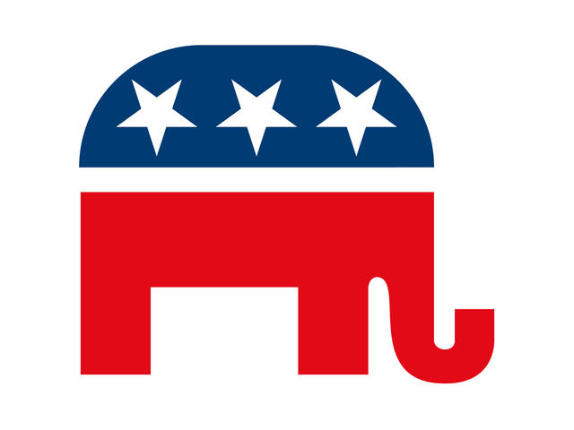

MIFFLIN COUNTY REPUBLICAN COMMITTEE

**Fall 2025 Banquet ticket prices:**

* Tickets: $35 each
* Candidates **OR** their representative coming on their behalf: $22 each
* Elected Officials: $22 each
* Donations/Ad booklet: those donating towards an Ad in our Spring booklet: $22 each
* Purchasing a **FULL** table of 8: $30 each = $240 for table