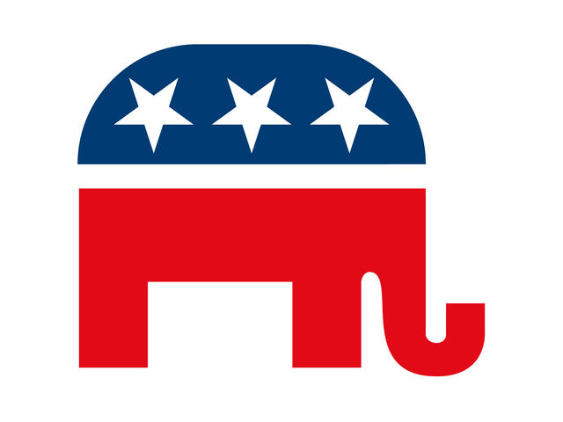

MIFFLIN COUNTY REPUBLICAN COMMITTEE

$175 Back Outside Cover-Color

$150 Inside Cover- Color

$100 Full page- Color

$75 Full page- Black & White

$60 ½ page- Color

$50 ½ page- Black & White

$30 ¼ page Color- (Business card size)

$25 ¼ page Black & White- (Business card size)

Patron Ads- $10 (Anonymous Ads not permitted)

Ads should be pdf and print ready. A setup fee of $30 will be added to the ones needing to be done by the printer. Campaign Finance laws are as follows: Personal or business checks are allowed. Cash is allowed. LLC is allowed. However, NO Corporations and NO Foreign Nationals.

Checks should be made out to **MC Republican Committee**.

PLEASE SEND ADS to [MifflinCoGOPChair@gmail.com](mailto:MifflinCoGOPChair@gmail.com). All ads and donations should be submitted by **September 17th, 2025.**

Questions to Juanita @ 717-994-6916

Send money to: PO Box 961, Lewistown, Pa 17044.

MifflinCoGOPChair@gmail.com